URL used to sample with:

<https://services.digitalglobe.com/mapservice/wmsaccess?connectid=a797f723-f91f-40d7-8458-3669a830b6de&SERVICE=WMS&REQUEST=GetMap&version=1.1.1&SRS=EPSG:4326&BBOX=-105.161,39.67,-104.756,39.88&WIDTH=1102&HEIGHT=712&LAYERS=DigitalGlobe:Imagery&format=image/jpeg&featureProfile=Cloud_Cover_Profile>

With the BBOX, Width, and Height entered in this version you can paste the URL directly into a browser for testing.

The following samples were chosen to display a little variety for our most commonly prescribed stacking profiles.

1. Accuracy_Profile: This profile returns high resolution features including those acquired using cameras mounted underneath aircraft and sub-meter satellite imagery. It favors high accuracy but currently suffers from issues regarding the way we calculate the "accuracy." This should stack with lowest (best) CE90 accuracy on top. CE90 accuracy defines an error circle such that for any point in an image at the center of such a circle, there is a 90% probability that the actual point will be located within that circle. For example, a CE90 accuracy of 4m means that for any point in that image the likelihood is 90% that the point you have selected is within 4 meters of its actual location on the globe. The CE90 accuracy is affected by the satellite instrumentation, atmospheric distortion, terrain, off-nadir angle (and other factors). There is a user story in place to improve our CE90 accuracy calculation and use it for this stacking profile.

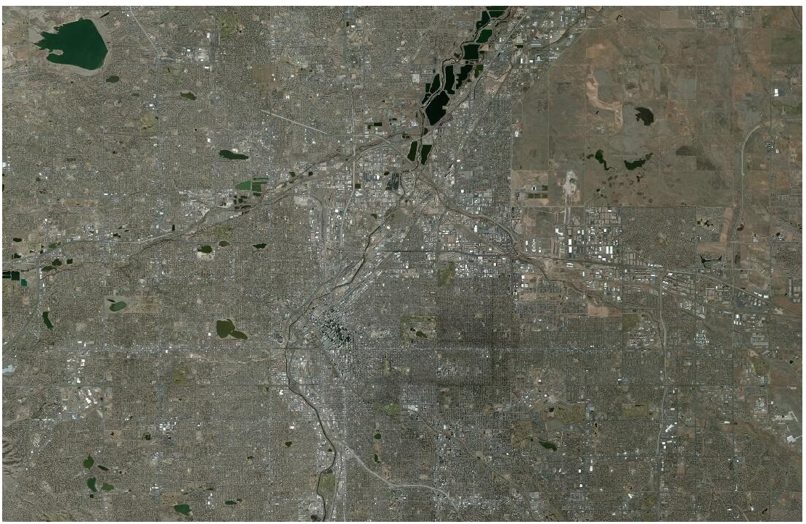

1. Cloud_Cover_Profile: This profile returns visible light features (color and panchromatic) with the lowest cloud cover on top. It then sorts by resolution, putting highest resolution features at the top of each cloud cover grouping. Those features having identical cloud cover and resolution are then sorted chronologically.

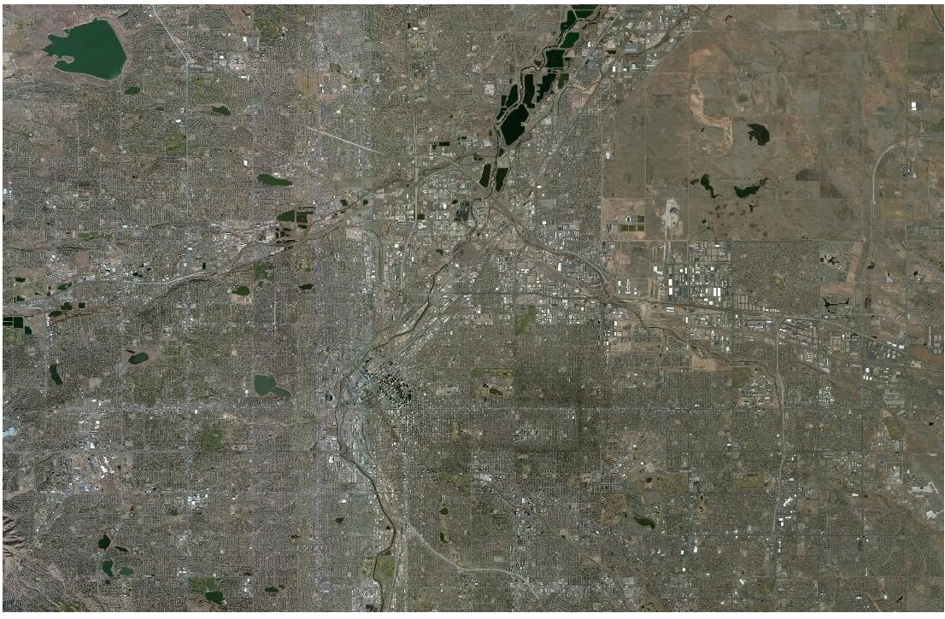

1. Global_Currency_Profile: This profile sorts all features (including infrared) chronologically, placing those features acquired most recently on top regardless of any other attribute. Thus a low resolution feature with high cloud cover may appear at the top of the stack as long as it is the most recently acquired feature.

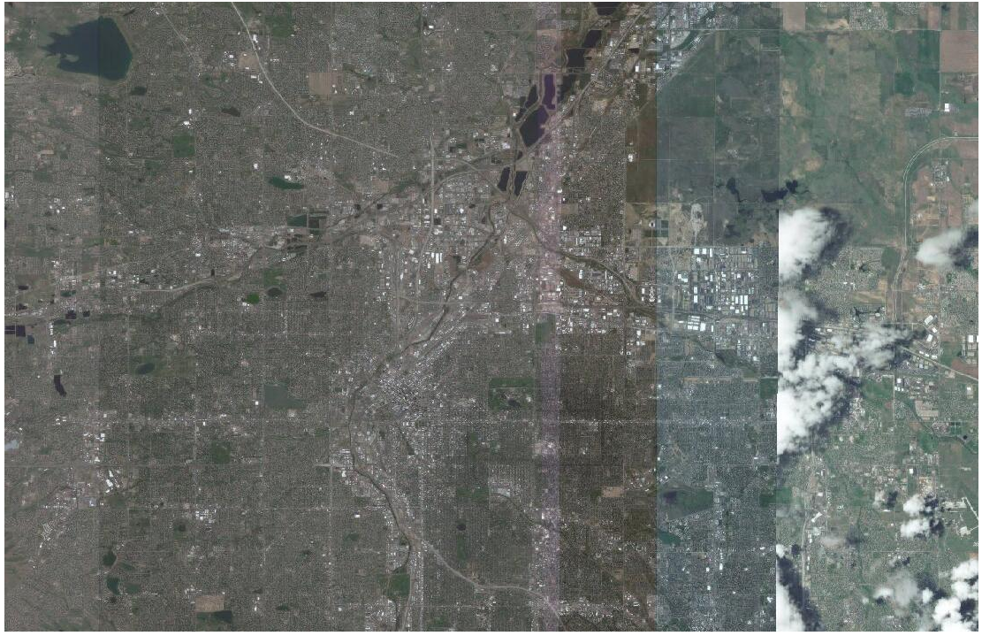

1. MyDG_Color_Consumer_Profile: This profile is intended to give users the aesthetically best color experience. It provides only visible light color imagery. Highest resolution imagery is on top sorted next by least cloud cover and then chronologically. This means that cloud cover may not increase uniformly as one moves down through the stack but may instead increase and then drop to a low level and increase again as one enters the next resolution group.

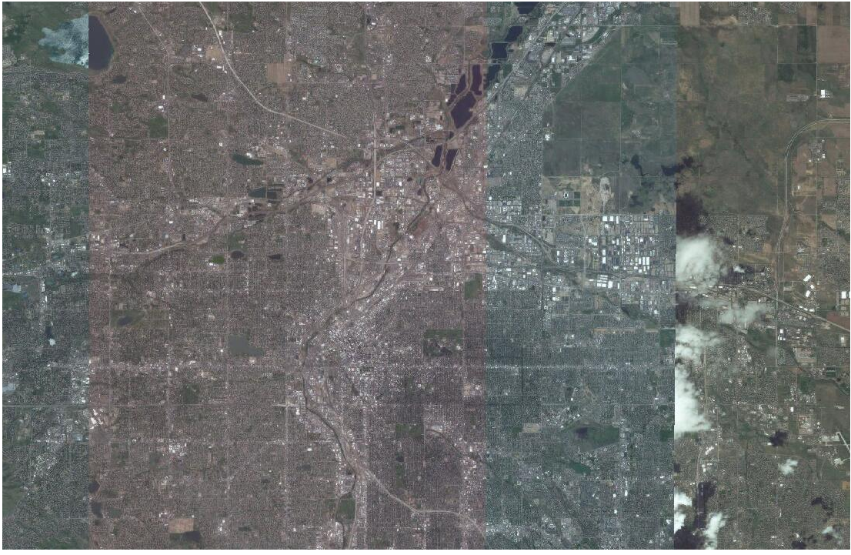

1. MyDG_Consumer_Profile: This profile is intended to give users the aesthetically best overall experience. It provides only visible light features. It sorts the features first by resolution with the highest resolution on top and then by cloud cover with the lowest cloud cover on top. Finally, features of identical resolution and cloud cover are sorted chronologically. This means that cloud cover may not increase uniformly as one moves down through the stack but may instead increase and then drop to a low level and increase again as one enters the next resolution group.

